Survey questions configurator documentation

Created by: Mohannad Al-Qudah
Date:2/23/2026
Version 1

Table of Contents
Table of figures 3
Introduction 4
Who is this for? 4
Overview 4
Limitations of the software 4
User Section 4
Section purpose 4
User guide 4
Main screen 5
Adding a question 5
Editing a question 6
Deleting a question 6
Sorting 7
Connecting to a different database 7
Changing the language 8
FAQs 8
Administrator Section 9
Section purpose 9
System Requirements 9
Installation Instructions 9
Trouble shooting 9
Developer section 10
Section purpose 10
Architecture and Design 10
Presentation layer (UI) 10
Service layer 10
Data Layer 10
Model Layer 10
Class diagram 11
Database Design 12
Real time update 12
Exception handling 12
Localization 13
Editing the Database Connection String 13
Custom Message Box Class 13
Logging 13
Naming conventions 13
References and further reading 14

Table of figures
Figure 1 Main screen 6
Figure 2 Add a question 6
Figure 3 Edit a question 7
Figure 4 Delete a question 7
Figure 5 Sorting 8
Figure 6 Change database connection 8
Figure 7 Language selection 9
Figure 8 Class diagram 12
Figure 9 Database Diagram 13

Introduction

Who is this for?
This document is intended for three types of audiences:
- End Users: To help them navigate and use the application effectively.
- System Administrators: To assist them in installing, configuring, and maintaining the application for users.
- Developers: To provide guidance on the software’s design and architecture, enabling them to continue developing and improving the application.

Overview
This software allows users to create, configure, and manage different types of questions for surveys. It currently supports three types of questions, which can be saved to the database users can also edit or delete existing questions as needed

Limitations of the software
Currently, the application supports only three types of questions Star Rating, Smiley Faces, and Slider. It does not provide user accounts, so individual users cannot store or manage their own questions separately.

User Section

Section purpose
The purpose of this section is to guide users in effectively using the application and to provide answers to any questions that may arise during its use.

User guide
From the main screen, users can create, view, edit, delete, sort questions, change database connection and choose a different language with step-by-step instructions provided in this guide.

Main screen
From this screen the user can see all of the questions from the database displayed in a list. They can click the buttons to add, edit, or delete a question, or click the column headers to sort them, additionally users can change the language of the application or change the database.
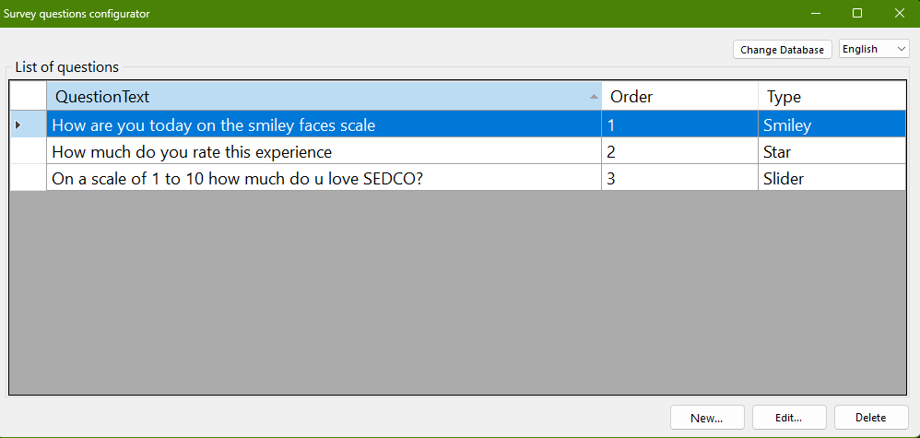
Figure 1 Main screen

Adding a question
Clicking the Add button opens a dialog that allows the user to create a new question. The user first enters the question name and sets its order, then selects the question type. Based on the selected type, different fields will be displayed for the user to complete. After filling in the required information, the user clicks the Save button to store the question in the database
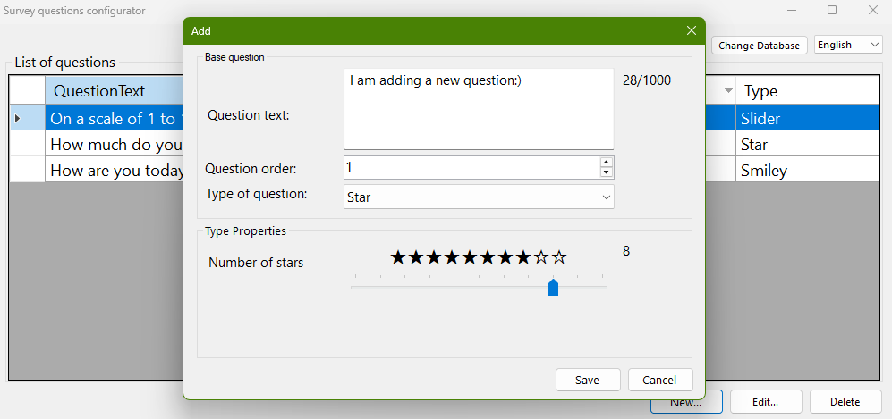
Figure 2 Add a question

Editing a question
Clicking the edit button will open a dialog with the selected question’s fields pre-filled. The user can modify any desired fields, including the question type If the question type is changed, the displayed fields will update accordingly, click the update button to save the changes to the database.
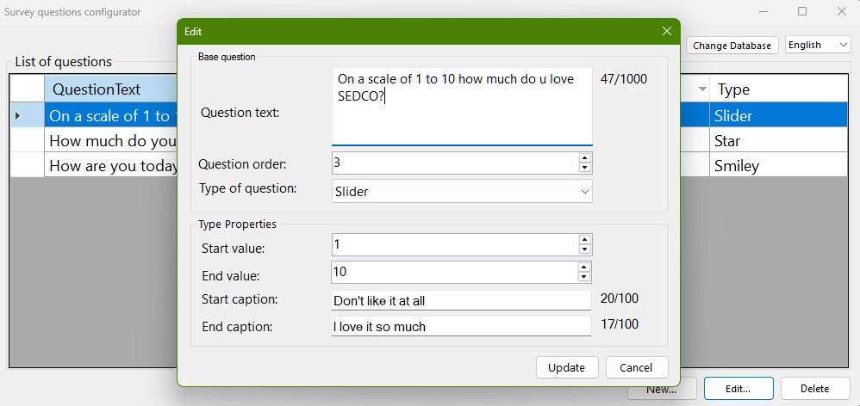
Figure 3 Edit a question

Deleting a question
After selecting a question from the list, the user can click the Delete button. A confirmation message will appear, and if the user confirms, the question will be permanently removed from the database.
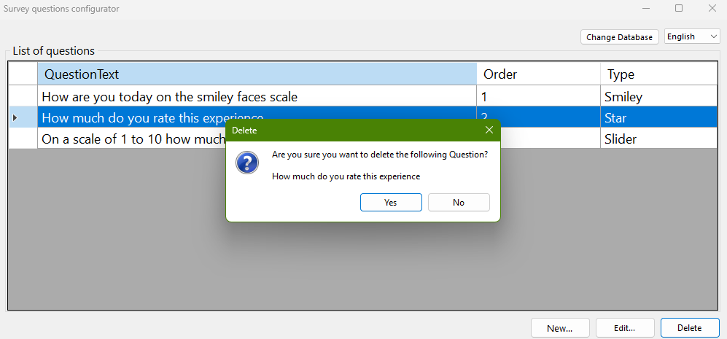
Figure 4 Delete a question

Sorting
At the top of the table, the user can click the column headers to sort the displayed questions by alphabetical order, order number, or question type. Clicking the same header again will reverse the sort order
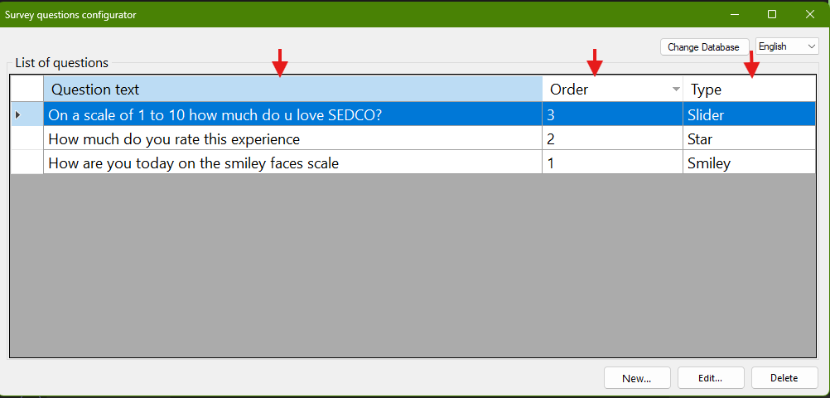
Figure 5 Sorting

Connecting to a different database
Clicking the Change Database button will open a dialog with the current connection string fields pre-filled. The user can modify the connection by updating the required fields, the user can click the Test Connection button to verify that the connection is valid. Clicking the Save button applies and stores the new database connection.
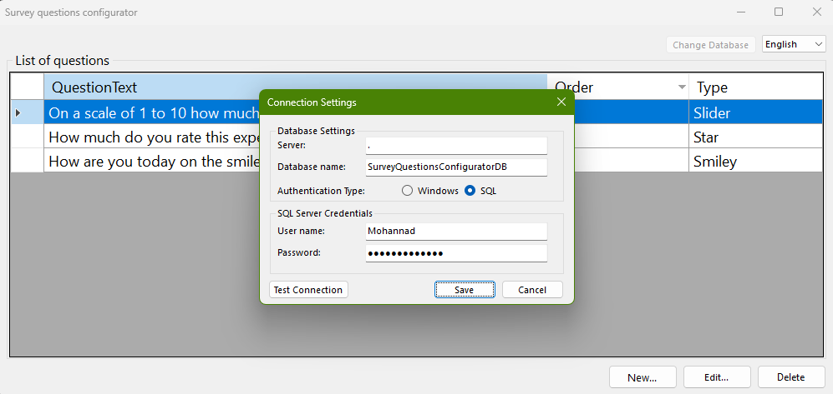
Figure 6 Change database connection

Changing the language
Clicking the language dropdown displays a list of available languages. Selecting a language from the list will change the application language to the selected one.
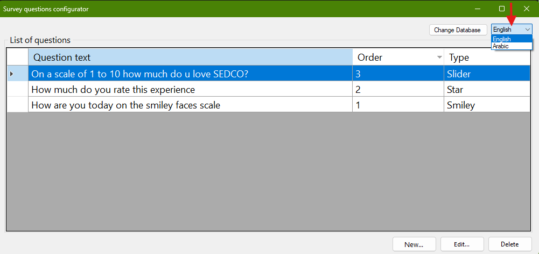
Figure 7 Language selection

FAQs
Q: I opened the application, but the questions are not showing.
A: The database may be temporarily unavailable. Please wait a moment and restart the application.
Q: Can I edit any question, regardless of who created it?
A: Yes. Currently, all questions in the application can be edited or deleted by any user.
Q: Can multiple users work on the application at the same time?
A: Yes, multiple users can access the application simultaneously. The application will automatically reflect changes made by other users in real time. However, there is no user-specific account system, so all changes affect the shared database
Q: What happens if I close the application without saving?
A: Any unsaved changes will be lost. Always click Save or Update before closing the application.

Administrator Section

Section purpose
This section is intended for system administrators who are responsible for installing, configuring, and maintaining the application on user computers.

System Requirements
- Operating System: Windows 7 ,8.1, 10,11
- Framework: .NET Framework version 4.7.2
- Database: Microsoft SQL Server

Installation Instructions
- Ensure that .NET Framework 4.7.2 is installed on the target machine.
- Install Microsoft SQL Server and ensure the database service is running.
- Create or restore the application database on the SQL Server instance using the SQL script.
- Copy or install the application files on the user’s PC.
- Ensure the database user specified in the connection string has the appropriate read/write permissions on the database.
- Configure the database connection string in the application configuration file (App.config).
Replace userID and Password with the actual credentials. Ensure a strong password is used.
<connectionStrings>
<add name="SurveyDb"
connectionString="Server=.;Database=SurveyQuestionsConfiguratorDB;User Id=userID;Password=Password;" />
</connectionStrings>
- Launch the application to verify that it connects successfully to the database.

Trouble shooting
- Questions are not displayed in the list:
Verify that the database is running and that the connection string in the configuration file is correct.
- Other errors reported by users:
Check the application’s logging folder, as all error messages and exceptions are recorded there for diagnosis.
- Application fails to start:
Ensure .NET Framework 4.7.2 is installed on the machine.

Developer section

Section purpose
This section is intended for developers who will work on the application. It provides detailed information about the technical decisions, design, and architecture of both the application and the database. The purpose is to help developers understand the structure and design of the application, continue development efficiently, debug issues effectively and Implement future modifications or enhancements.

Architecture and Design
The application is designed using a N-Tier Architecture, which separates the system into distinct layers.

Presentation layer (UI)
Implemented using Windows Forms and provides the user interface for interacting with the application. It is responsible for displaying data, capturing user input, and updating the UI in response to events raised by the service layer, while containing no business or database logic.

Service layer
Acts as an intermediary between the presentation and data layers. It contains validation logic and coordinates operations between the UI and the repository, keeping business rules separate from both the UI and database access.

Data Layer
Handles all interactions with the SQL Server database using ADO.NET, encapsulating the logic for creating, reading, updating, and deleting questions, and keeping database access separate from both the UI and business logic

Model Layer
Is a separate class library containing the application’s entities, such as Question and its specialized types and result class. This layer is shared across the UI, service, and repository layers and contains no database or UI logic.

Class diagram
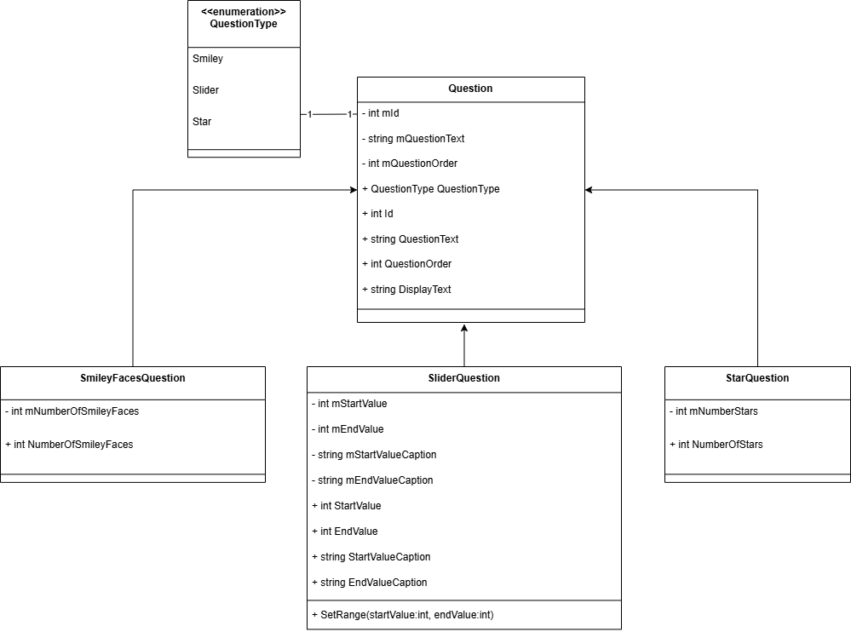
Figure 8 Class diagram
An abstract Question class is used to represent the common structure of all questions. Specific question types inherit from this class and implement their own logic. Each question includes a QuestionType property, implemented as an enumeration, which explicitly identifies the type of the question. This provides type safety, improves readability, and avoids the use of hard coded values throughout the system.
This design allows shared validation and behavior to be implemented once in the base class. It also makes the system flexible and easy to extend, as new question types can be added without modifying existing implementations.

Database Design
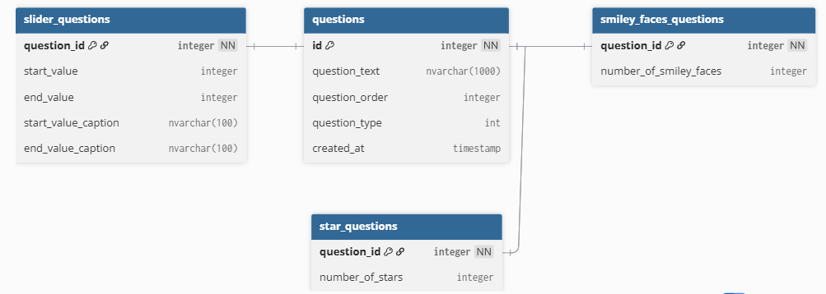
Figure 9 Database Diagram

The database design is based on a base table called Question, where each specific question type has a one-to-one relationship with the Question table. Whenever a new base question is added, the generated primary key is reused to create a corresponding record in a corresponding record in the specific question type's table. This design mimics inheritance in C#, allowing each question type to store only its relevant fields. It avoids having a single large table with many nullable columns for different question types and makes the schema easier to maintain. Additionally, this approach allows new question types to be added easily without affecting existing tables or data.

Real time update
To support real time updates and allow multiple users to use the application simultaneously, the application uses the SqlTableDependency library along with SQL Server Service Broker. When enabled, Service Broker allows SQL Server to send a notification message to the application whenever a change occurs in the database. The application subscribes to the OnChanged event of SqlTableDependency, which triggers every time a change is detected. This event propagates from the repository layer to the service layer, which then notifies the UI. The UI can then request a fresh list of questions to reflect the latest data.

Exception handling
The application uses a Result pattern to handle errors and operation outcomes instead of relying on exceptions for normal control flow. A generic Result<T> class is used to encapsulate the outcome of service and repository operations by indicating whether an operation succeeded and, if not, providing an appropriate result status showing the type of error.
Expected failure scenarios, such as invalid user input, validation errors, or attempts to perform operations with invalid identifiers, are handled by returning a failed Result<T> object. This allows the service layer to enforce business rules and return meaningful feedback without throwing exceptions.
Unexpected exceptions, such as database connectivity failures or unhandled runtime errors, are caught at the repository layer, logged using Serilog, and returned as a failed Result<T> object with an error result status to avoid exposing internal details to the UI

Localization
The application supports localization, allowing the user interface to be displayed in multiple languages. All UI text is stored in language resource files, which enables the application to dynamically switch between supported languages.
Developers can add new languages by creating additional resource files and providing translations for the required UI strings.

Editing the Database Connection String
The application provides functionality to modify the database connection string at runtime. The Change Database dialog allows users to update the connection parameters, such as server name, database name, username, and password. The dialog also includes a Test Connection feature to validate the connection before saving the changes. Once saved, the updated connection string is used by the application for all subsequent database operations.

Custom Message Box Class
The application uses a custom Message Box class to standardize dialog messages across the system. This class provides a consistent user interface for displaying informational messages, warnings, errors, and confirmations. The custom implementation allows additional control over styling, localization support, and behavior.

Logging
The application uses Serilog as its logging framework to record application events, errors, and operational information. Logs are written in JSON format and stored in a file, which allows structured and machine readable logging. Using structured JSON logs makes it easier to search, filter, and analyze log data, especially when troubleshooting issues or reviewing application behavior.

Naming conventions
Element Type | Naming Convention | Example
Class | PascalCase | QuestionService
Interface | PascalCase (prefixed with I) | IQuestionRepository
Enum | PascalCase | QuestionType
Enum Values | PascalCase | Star
Public Property | PascalCase | QuestionText
Private / Internal Field | m + PascalCase | mDataRepository
Method | PascalCase | GetAllQuestions()
Method Parameter | p + PascalCase | pQuestion
Local Variable | t + PascalCase | tResult
Constants | UPPER_CASE_WITH_UNDERSCORES | MAX_QUESTION_LENGTH

References and further reading
Overview - ADO.NET | Microsoft Learn
Detecting Changes with SqlDependency - ADO.NET | Microsoft Learn
Serilog — simple .NET logging with fully-structured events
The Result Pattern in C#: A Smarter Way to Handle Errors | by Aseem | Medium
How to Represent Inheritance in a Database? Baeldung on SQL
How to design UX for desktop applications - Win32 apps | Microsoft Learn
Command Buttons in Windows 7 - Win32 apps | Microsoft Learn
Layout Specifications: Windows Forms | Microsoft Learn
Thank you for using the Survey Questions Configurator. I hope this guide helps you get the most out of the application.

